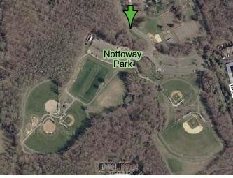
#
#2
#3
Baseball Fields

